Register Availability using the Website
You can either register availability by the Website or by the App.

Website
- Go to www.pitchero.com
- Click Login
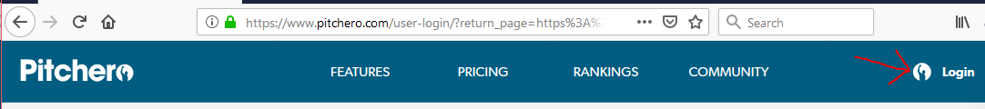
- Login using your account.
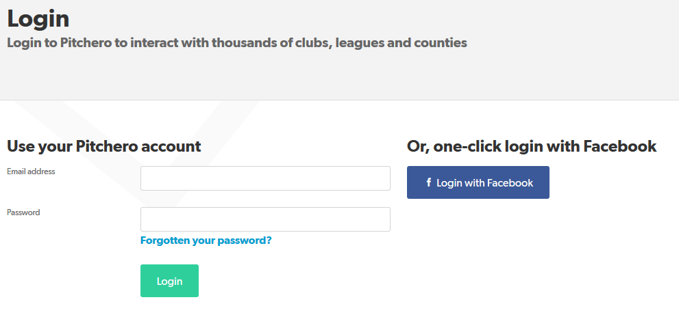
- Click on the indicated box
- Select ‘Your Account’
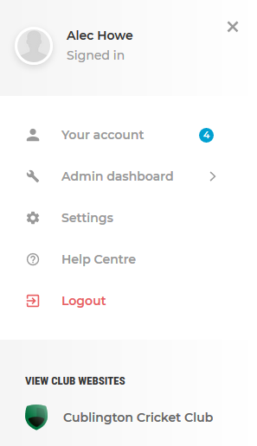
- Select Schedule

- Click on ‘Set Availability’ for the date you want
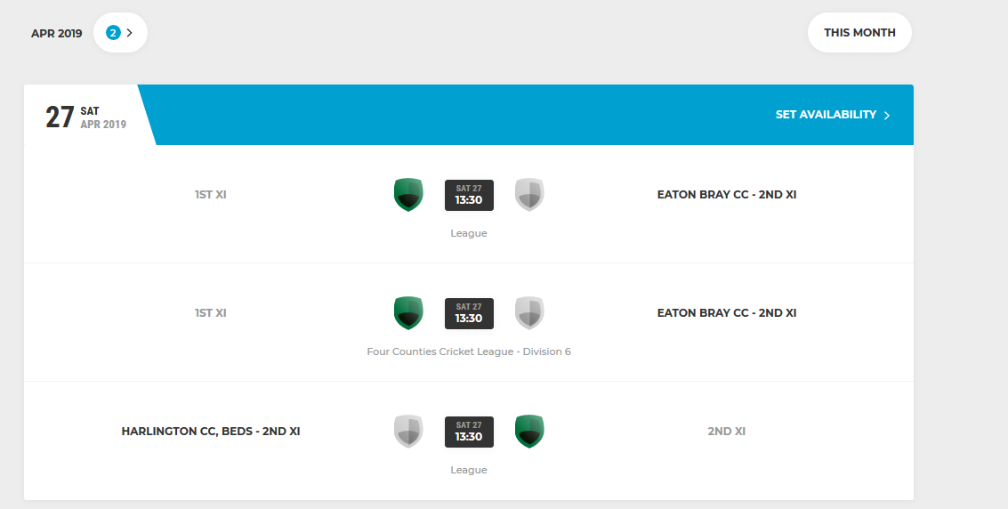
- There will then be a box on the right of the screen as shown here.
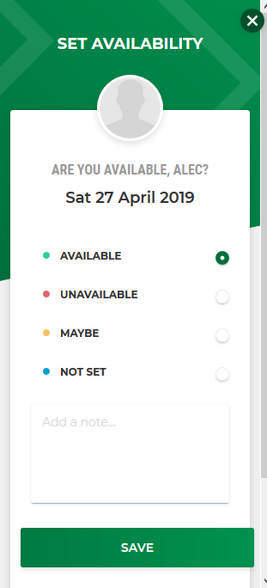
- Click the tickbox next to the relevant option.
- Add a note if needed
- Click Save
- You’ll then see the same box as previously now indicating your availability
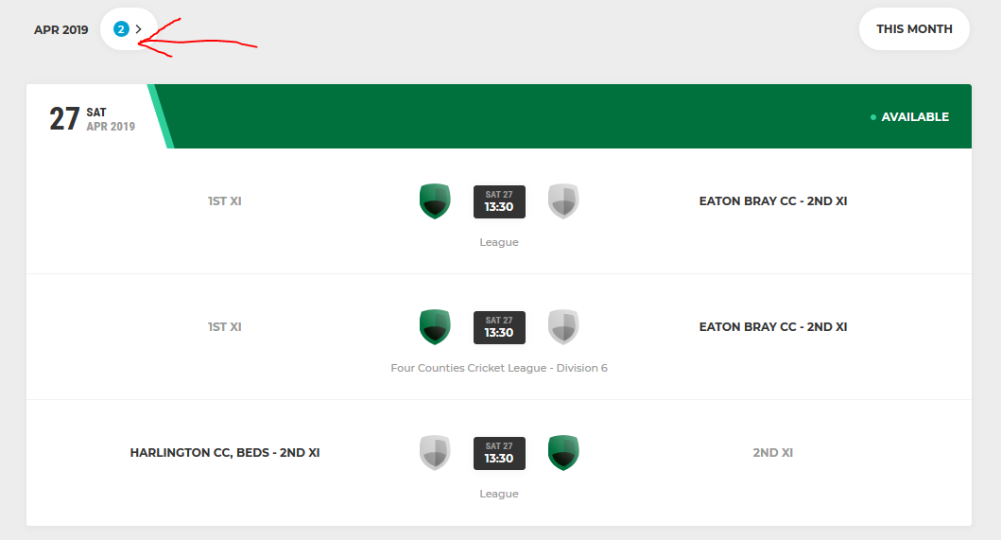
To find more fixtures in the same month scroll down, or to move to a different month click on the arrow next to the month at the top as indicated by the arrow.

