Register Availability using the Pitchero Club App
You can either register availability by the Website or by the App.

App
- Open the Pitchero Club App
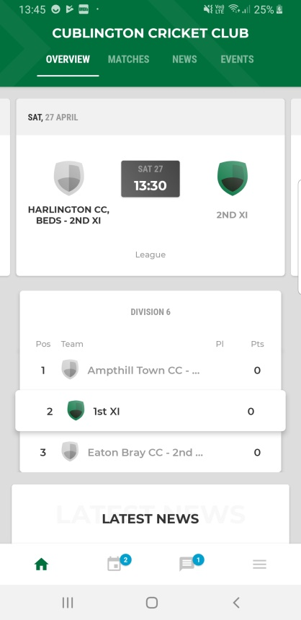
- Select Schedule (the calendar icon)

- This brings you to the ‘My Schedule’ screen.
To set your availability for a game, click the ‘set availability’ button
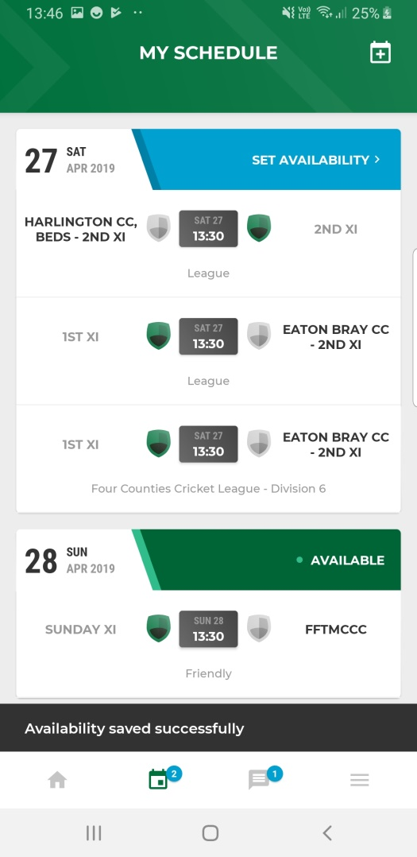

- Select the tickbox next to the relevant availability. When this is done it will be green (as the ‘not set’ is here).
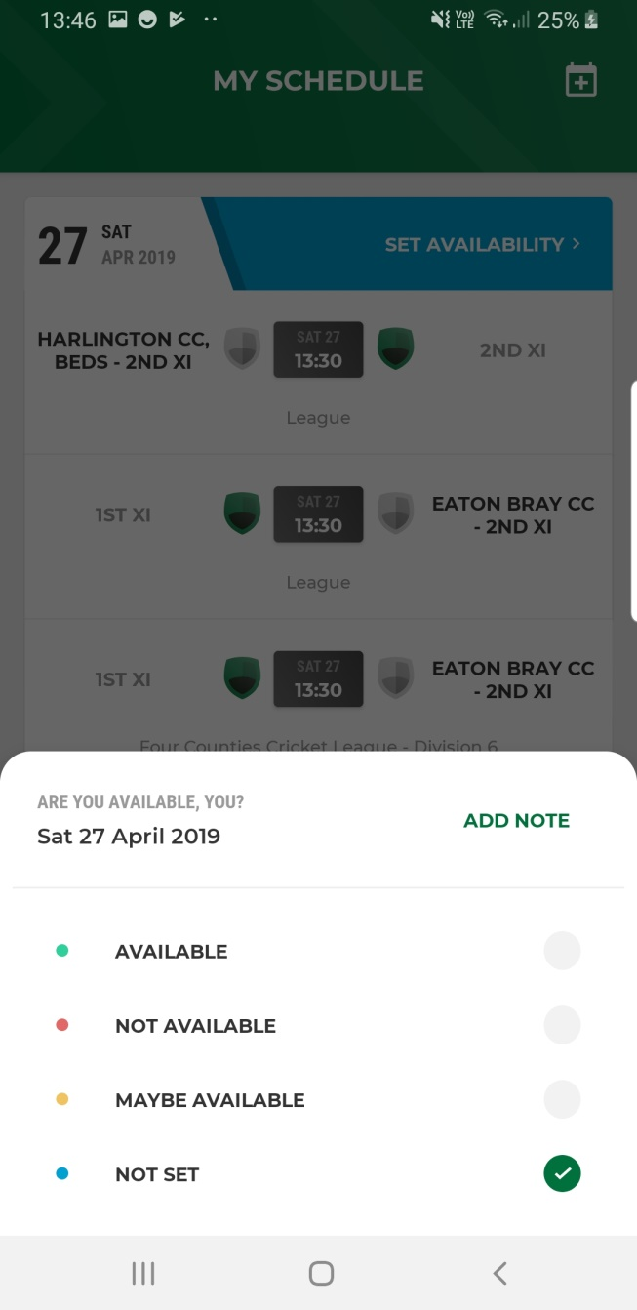
- If you wish to add a note, click the ‘add note’ button and write what you want.
- After this you will be taken back to the previous screen but the availability will be updated for that match.
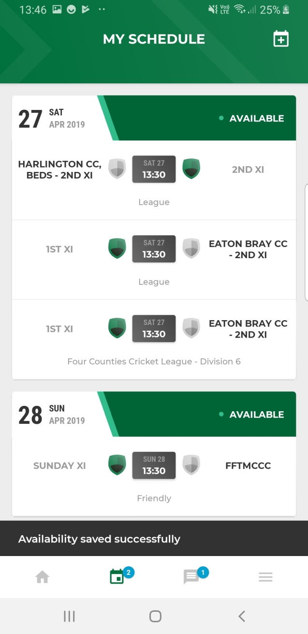
To update your availability for any other days/games, just scroll down and click on the ‘Set availability’ button next to each game.

